 `SRI KRISHNA COLLEGE OF THCHNOLOGY

**AnAutonomous Institution | Accredited by NAAC with 'A' Grade**

**Affiliated to Anna University | Approved by AICTE**

**KOVAIPUDUR, COIMBATORE 641042**

**ONLINE BOAT HOUSE BOOKING**

**A PROJECT REPORT**

**Submitted by**

|  |  |
| --- | --- |
| HARISH RAGAVENDRA | **727821TUIT033** |
| AARTHI DJ | **727821TUIT002** |
| KAVIN KUMAR | **727821TUIT049** |

in partial fulfillment for the award of the degree

Of

**BACHELOR OF TECHNOLOGY**

**IN**

**INFORMATION TECHNOLOGY**

**MARCH 2024**

# CERTIFICATE



II

# BONAFIDE CERTIFICATE

Certified that this project report **“ONLINE BOAT HOUSE BOOKING**

**APPLICATION”** is the Bonafide work of

**HARISH RAGAVENDRA A, AARTHI DJ,KAVIN KUMAR** who carried out the project work under my supervision.

**SIGNATURE SIGNATURE**

**Mrs.P.Dhivya Dr.S .SIAMALA DEVI**

## SUPERVISOR HEAD OF THE DEPARTMENT

Assistant professor, Assistant Professor, Department of Department of

Information Technology, Information technology,

Sri Krishna College of Technology, Sri Krishna College of Technology,

Coimbatore-641042 . Coimbatore-641042 .

Certified that the candidates were examined by us in the Project Work viva- voce examination held on at Sri Krishna College of Technology, Coimbatore -641 042.

**INTERNAL EXAMINER EXTERNAL EXAMINER**

# 

# ACKNOWLEGDEMENT



III

# ACKNOWLEDGEMENT

Dedicating this project to the **ALMIGHTY GOD** whose abundant grace and mercies enabled its successful completion.

We extend our deep gratitude to our beloved Principal, **Dr. M. G. Sumithra,** for her kindness and unwavering support throughout the project work.

We are grateful to our beloved Dean Academics affairs and assessment

**Dr. R. Rameshkumar,** for his tireless and relentless support.

We extend our heartfelt thanks to our beloved Dean Accreditation and Ranking **Dr.**

**P. Manju,** for her advice and ethics inculcated during the entire period of our study.

We would like to express our deep gratitude to **Dr. J. Shanthini,** Head of Computing Science and **Dr. S. Siamala Devi,** Head of Information Technology , for her exceptional dedication and care towards success of this project.

We would like to extend our heartfelt gratitude to our Project guide **Mrs.P.Dhivya,** Assistant Professor, Department of Information Technology for her valuable guidance and suggestion in all aspects that aided us to ameliorate our skills.

We are thankful to all those who have directly and indirectly extended their help us in completing this project work successfully.

# ABSTRACT



IV

# ABSTRACT

The Online boat house booking is a user-centric online platform designed to cater to chess enthusiasts of all levels, offering a curated selection of academies and courses to facilitate effective learning. Users can seamlessly navigate through the portal to explore detailed information about various academies, each distinguished by unique teaching methodologies and experienced faculty profiles. The curated courses cover a wide spectrum of chess fundamentals, strategies, and advanced techniques, ensuring a structured learning experience tailored to individual needs. With an intuitive enrollment system, users can easily sign up for courses of interest, track their progress, and access a range of learning materials such as video lectures, quizzes, and practice exercises. The portal also fosters community interaction, providing forums for discussions, collaboration opportunities, and expert guidance from instructors. Whether users are beginners seeking to grasp the basics or seasoned players aiming for mastery, the Chess Academy Portal offers a comprehensive and engaging platform for honing chess skills and achieving strategic prowess.

# TABLE OF CONTENT



V

# TABLE OF CONTENT

**CHAPTER NO TITLE PAGE NO**

**ABSTRACT IV**  **LIST OF FIGURE VI**

**LIST OF ABBREVIATION VIII**

1. **INTRODUCTION** 
   1. PROBLEM STATEMENT 1
   2. OVERVIEW 1
   3. OBJECTIVE 2 **2 METHODOLOGIES**
   4. HISTORY 3
   5. PURPOSE 3
2. **SYSTEM SPECIFICATIONS** 
   1. SOFTWARE REQUIREMENTS 4 **TOOLS AND TECHNOLOGIES**
3. **USED** 
   1. HTML 5
   2. CSS 6
   3. JAVASCRIPT 7 **5 IMPLEMENTATION**
   4. UML DIAGRAM 8
   5. FRONT- END 13
4. **CONCLUSION 46**

6.1 FUTURE SCOPE

1. **REFERENCES 47**

# LIST OF FIGURES



VI

# LIST OF FIGURES

|  |  |  |
| --- | --- | --- |
| **CHAPTER NO** | **TITLE** | **PAGE NO** |
| 3.1 | VISUAL STUDIO | 4 |
| 4.1 | HTML | 6 |
| 4.2 | CSS | 6 |
| 4.3 | JAVASCRIPT | 7 |
| 5.1 | USE CASE DIAGRAM | 8 |
| 5.2 | CLASS DIAGRAM | 9 |
| 5.3 | SEQUENCE DIAGRAM | 10 |
| 5.4 | ACTIVITY DIAGRAM | 11 |
| 5.5 | ER DIAGRAM | 12 |
| 5.6 | ENHANCED ER DIAGRAM | 13 |
| 5.7 | FRONT END | 14 |
| 5.8 | HOME PAGE | 14 |
| 5.9 | LOGIN PAGE FLOWCHART | 16 |
| 5.10 | LOGIN PAGE | 17 |
| 5.11 | REGISTER PAGE FLOWCHART | 20 |
| 5.12 | REGISTER PAGE | 20 |
| 5.13 | TODAY PAGE | 22 |
| 5.14 | HISTORY PAGE | 25 |
| 5.15 | SUGGESTER PAGE | 27 |
| 5.16 | FEEDBACK PAGE | 30 |
| 5.17 | FAQ PAGE | 32 |

VII

|  |  |  |
| --- | --- | --- |
| 5.18 | ABOUT PAGE | 34 |
| 5.19 | PRIVACY POLICY PAGE | 36 |
| 5.20 | TERMS & CONDITIONS PAGE | 38 |
| 5.21 | FOOTER | 40 |

# LIST OF ABBREVATIONS



VIII

# LIST OF ABBREVATIONS

|  |  |
| --- | --- |
| **ABBREVATIONS** | **ACRONYMS** |
| HTML | **HYPERTEXT MARKUP LANGUAGE** |
| CSS | **CASCADING STYLE SHEET** |
| JS | **JAVASCRIPT** |
| DOM | **DOCUMENT OBJECT MODEL** |

# INTRODUCTION



1

CHAPTER 1

INTRODUCTION

This chapter delves into the realm of chess education, highlighting its enduring allure and educational significance. The Chess Academy Portal brings the world of chess directly to users' screens, offering live-streamed and pre-recorded sessions, expert guidance, and cutting-edge technology to provide an immersive learning experience. Whether users are seasoned chess players or newcomers to the game, these academies offer a front-row seat to explore the intricacies of chess strategy, tactics, and gameplay.

1.1 PROBLEM STATEMENT

The Chess Academy Portal serves as a comprehensive online platform connecting chess enthusiasts with academies, simplifying the process of exploring courses, enrolling in them, and enhancing chess skills. It addresses the challenge of finding structured and engaging chess education resources by curating courses from experienced instructors and providing a centralized hub for users to access them.

1.2 OVERVIEW

The Chess Academy Portal project aims to create an interactive and educational web-based platform for users to discover, enroll in, and participate in chess academies and courses. It facilitates a seamless experience for users to explore a variety of academies, review course details, and enroll in courses that match their skill levels and learning objectives. Additionally, the portal offers features such as progress tracking, community forums, and expert guidance to enhance the overall chess learning experience.

1.3 OBJECTIVE

The objective of the Chess Academy Portal project is to develop a user-centric platform that empowers chess enthusiasts to expand their knowledge and skills. It aims to simplify the process of finding and enrolling in chess academies while providing a range of features such as progress tracking, interactive lessons, and community engagement. Key goals include ensuring accessibility across devices, integrating a secure payment system for course enrollment, and implementing personalized recommendations based on users' chess proficiency and interests. Ultimately, the project seeks to foster a vibrant and thriving chess community by offering a diverse range of educational opportunities and resources.

# METHODOLOGIES



3

CHAPTER 2

METHODOLOGIES

2.1 HISTORY

The evolution of chess academies and educational platforms has been deeply intertwined with the rich history of chess as a game of strategy and intellect. Historically, chess education was often limited to in-person coaching sessions, chess clubs, and printed instructional materials. However, with the advent of digital technology and online learning platforms, the landscape of chess education has transformed significantly. Online chess academies have emerged as a modern solution, offering a virtual space for chess enthusiasts to learn, practice, and improve their skills remotely.

Today, the Chess Academy Portal represents the culmination of this historical progression. This contemporary platform leverages digital advancements to provide a comprehensive and accessible learning experience for chess enthusiasts worldwide. By harnessing the power of technology, the portal aims to democratize chess education and make it more inclusive and engaging for learners of all backgrounds.

2.2 PURPOSE

The core purpose of the Chess Academy Portal is to create a dynamic and user-friendly online platform that connects chess enthusiasts with top-tier academies and educational resources. It aims to revolutionize the way people learn and master chess by offering a diverse range of courses, interactive lessons, and expert guidance. The portal's primary objectives include providing advanced search and recommendation features to help users discover relevant courses, offering a seamless enrollment process, and fostering a vibrant community of chess learners and instructors.

ENVIRONMENTAL SETUP

The Chess Academy Portal is designed to thrive in a digital environment, leveraging cutting-edge technology to deliver a seamless and immersive learning experience. The platform is built on robust infrastructure and utilizes secure payment gateways to ensure a safe transaction process for course enrollments. Additionally, the portal is optimized for cross-device compatibility, allowing users to access courses and learning materials from desktops, laptops, tablets, and smartphones with ease. Overall, the environmental setup of the Chess Academy Portal is geared towards providing users with a hassle-free and enriching chess education experience.

# ENVIRONMENTAL SETUP



4

**CHAPTER 3 ENVIRONMENT SETUP**

# 3.1 INSTALLATION OF VISUAL STUDIO CODE

A software package known as an integrated development environment, or IDE, integrates the essential tools required to design and test software. Developers use a range of tools for writing, creating, and testing software code. Examples of development tools include text editors, code libraries, compilers, and test environments. Developers can give commands immediately on VSC without needing to open a terminal process thanks to a built-in terminal system on VSC, which makes it easier to check for errors. The fact that VSC comes with a built-in GIT command that enables diff checking, staging files, and committing directly from the editor is another reason to choose it.

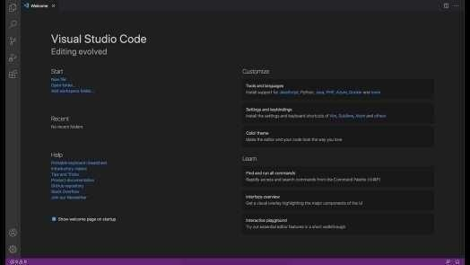

## Fig 3.1 Visual Studio

The upcoming chapter discusses the tools and technologies used such as HTML, CSS, JAVASCRIPRT.

# TOOLS AND TECHNOLOGIES USED

5

## CHAPTER 4 TOOLS AND TECHNOLOGIES USED

Multiple technologies and applications were employed in the "buy casa" project.

4.1. HTML

4.2. CSS

4.3. JavaScript

### 4.1 HTML

Hypertext Markup Language is referred to as HTML. To create web pages, this language is utilized. The creation of interactive and responsive pages on the pages is also supported by this language, along with other languages like CSS, PHP, JAVASCRIPT, etc. Simply put, HTML5 is HTML in a more modern form. It enables brand-new functions, characteristics, HTML components, video and audio, as well as 2D and 3D images, all of which are helpful to users and web designers in their ability to easily add brand-new functions to websites. Figure illustrates the structure of HTML5.

6

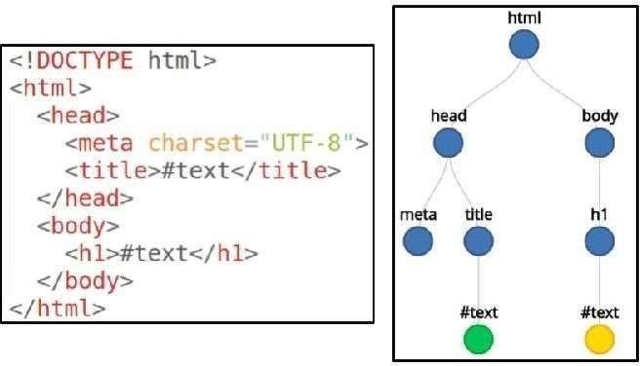

**Fig 4.1 HTML**

### 4.2 CSS – CASCADING STYLE SHEET

Cascading Style Sheets is the short name for CSS. CSS is used to specify the design, layout, and display variants for web pages on various devices and screen sizes. The basic organization of CSS is as

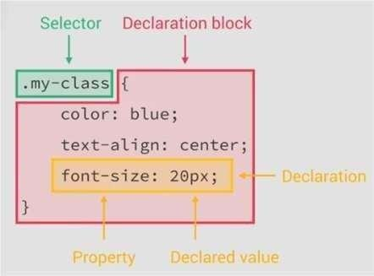

**Fig 4.2 CSS**

**7**

### 4.3 JAVASCRIPT

A JavaScript-based UI development library is called React. It is managed by Facebook and an open source development community. The library made its debut in May 2013 and is currently one of the frontend libraries for web development that is most frequently used. Our React project folders are as follows:

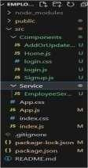

#### Fig 4.3 Javascript

The upcoming chapter will explain the UML diagrams involved such as usecase activity, sequence, ER, ERR diagrams.

## IMPLEMENTATION

8

## CHAPTER 5 IMPLEMENTATION

In this chapter the detailed explanation of the project will be seen. How the front-end i.e., the UI works.

## 5.1 UML DIAGRAM

Unified Modeling Language (UML) diagrams are a standardized

visual representation of a system's structure and behavior. UML is a widely used for designing, documenting, and communicating the architecture and functionality of a system.

### 5.1.1 USE CASE DIAGRAM

A Use Case Diagram is a visual representation in the Unified Modeling Language (UML) that provides an overview of the functional requirements of a system or software application.

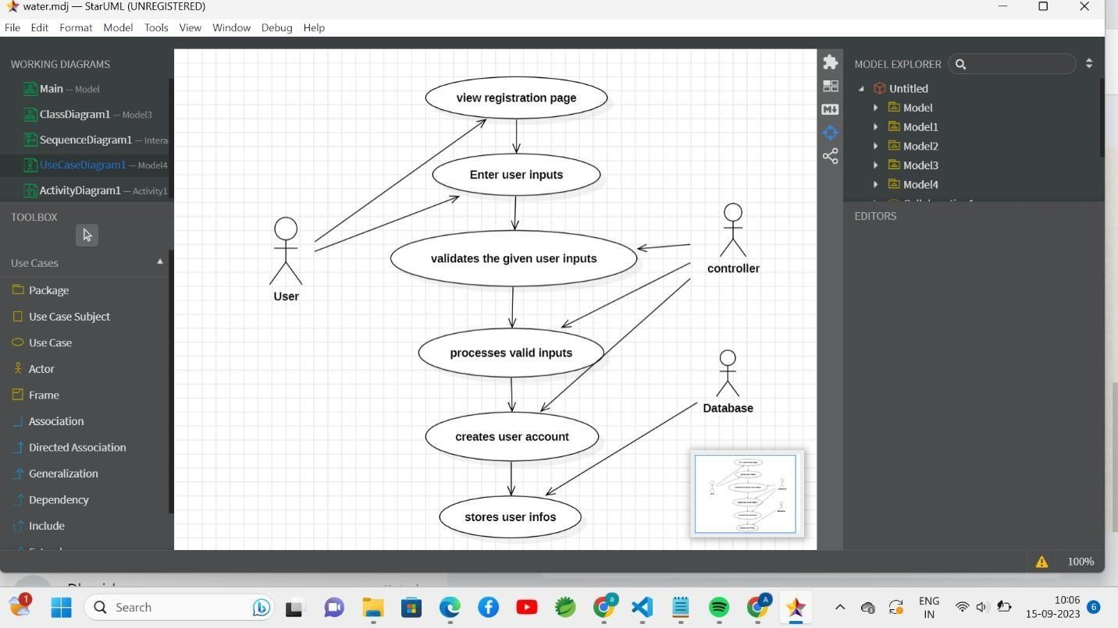

#### Fig 5.1 Use case diagram

9

### 5.1.2 CLASS DIAGRAM

A class diagram is a type of diagram in the Unified Modeling Language (UML) that represents the structure and relationships of the classes or objects in a software system.

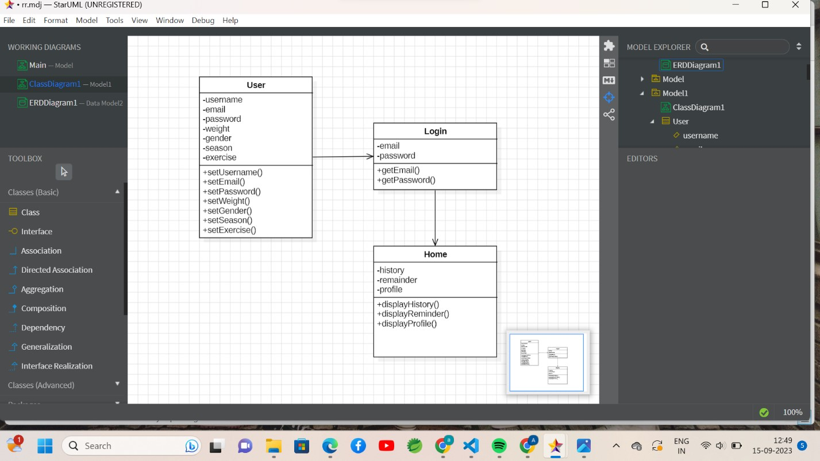

**Fig 5.2 Class diagram**

### 5.1.3 SEQUENCE DIAGRAM

A sequence diagram is a type of interaction diagram in UML (Unified Modeling Language) that visually represents the interactions and messages exchanged among objects or components in a system or software application over time.

10

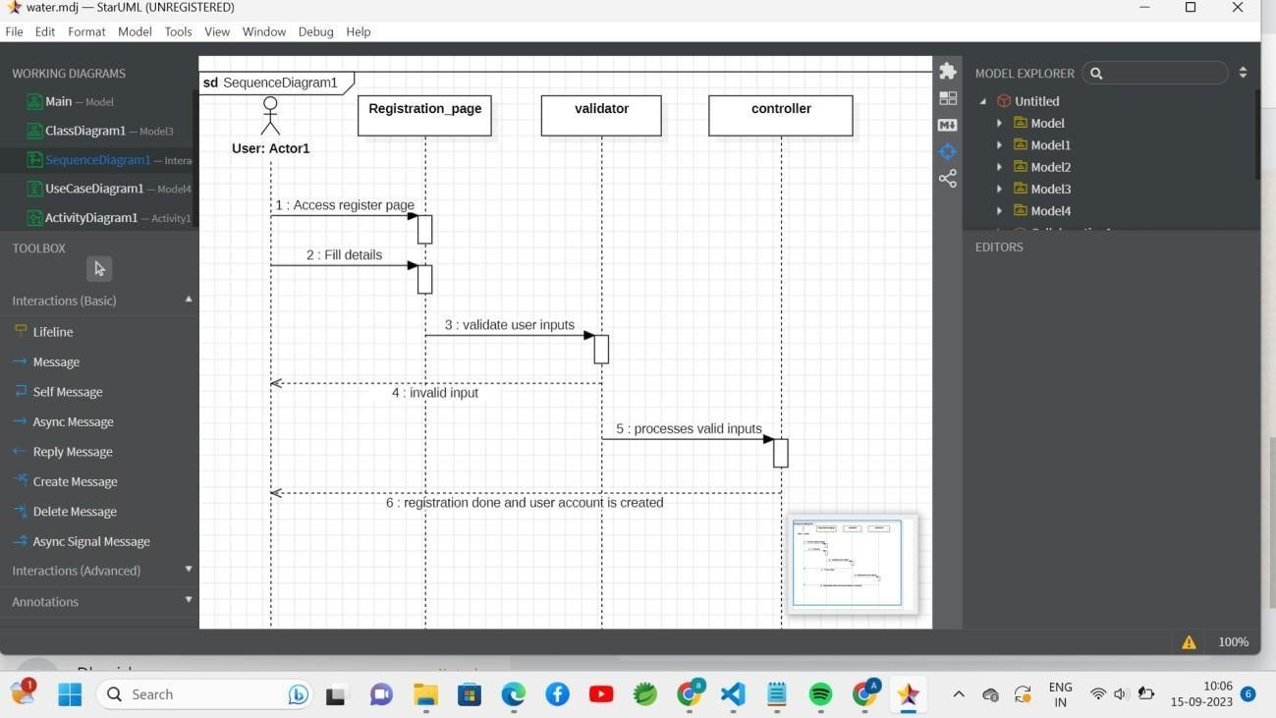

**Fig 5.3 Sequence diagram**

### 5.1.4 ACTIVITY DIAGRAM

An activity diagram is a type of diagram used in Unified Modeling Language (UML) and other modeling methodologies to visualize and describe the flow of activities or processes within a system, software application, or business process.

11

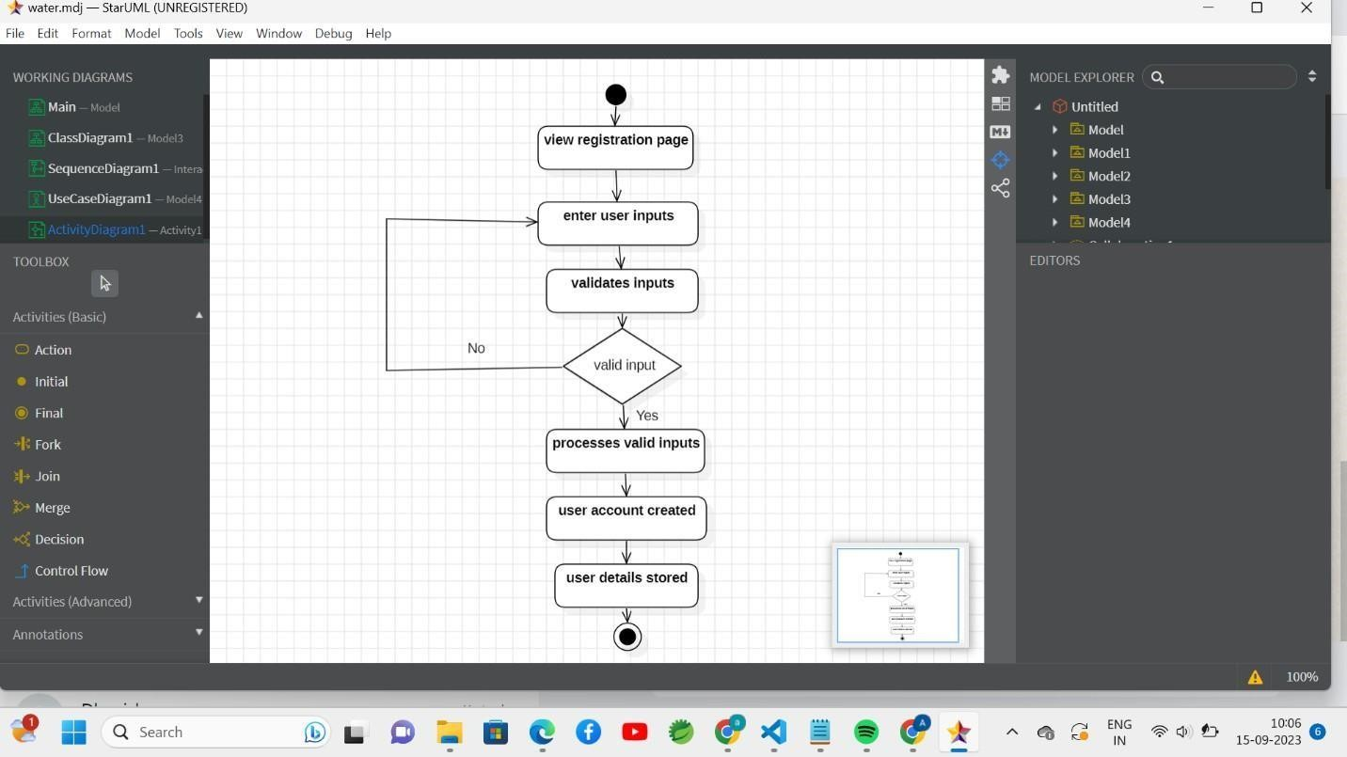

**Fig 5.4 Activity diagram**

### 5.1.5 ENTITY – RELATIONSHIP DIAGRAM

An Entity-Relationship Diagram (ERD) is a visual representation used

in database design and modeling to depict the structure and relationships of data within a system.

**Fig**

**5.5**

**ER**

**Diagram**

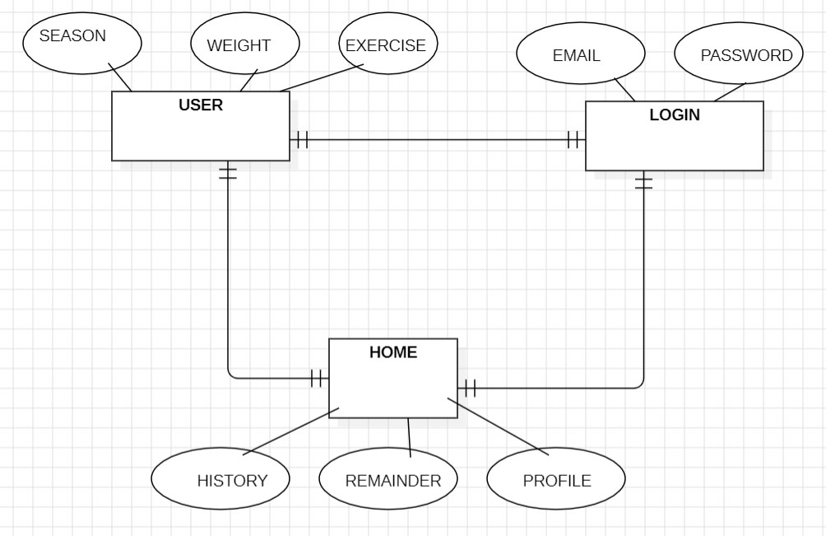

### 5.1.6 ENHANCED – ER DIAGRAM

An Enhanced Entity-Relationship Diagram (ERD) is an extension of the

traditional Entity-Relationship Diagram (ERD) used in database design. It includes additional modeling concepts and notations to capture more complex relationships and attributes within a database schema.

**F**

**ig 5.6**

**Enhanced**

**ER**

**Diagram**

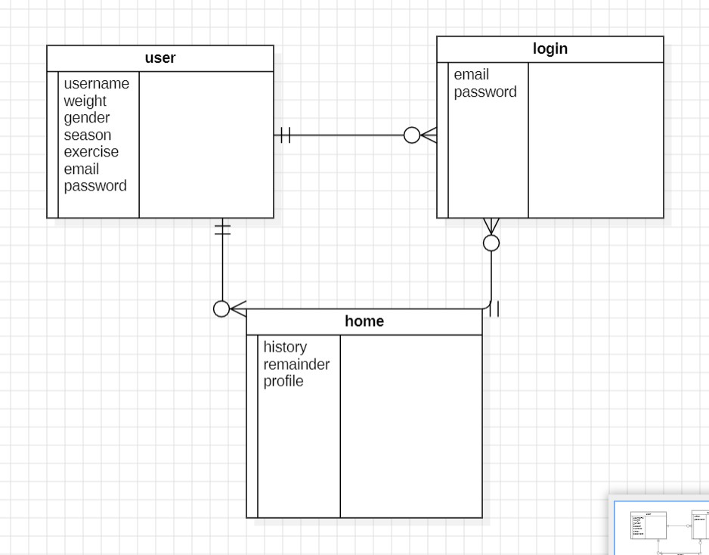

## 5.2 FRONT-END

A front-end developer is a type of software developer who specializes

in creating and designing the user interface (UI) and user experience (UX) of websites and web applications. The primary responsibility of a front-end developer is to ensure that the visual and interactive aspects of a website or application are user- friendly, aesthetically pleasing, and functionally efficient.

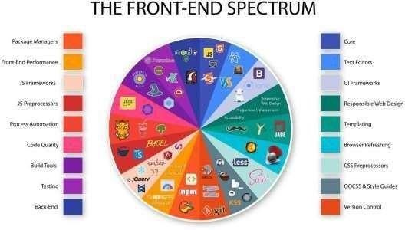

**Fig 5.7 Front-End**

### 5.2.1 HOME PAGE

A Home page is a page where the projects first and foremost page begins

where it contains the project description and it contains top bar, side bar which displays activities, contact us, logout.



**Fig 5.8 Home page**

15

**Js code :**

import React from 'react' import

'./HomePage.css'

import sports_icon from '../Fpage/simplistic-sportswoman-taking-selfie-after- sports-training.png';

import fatigue from '../Fpage/fatigue.jpg'

import woman from

'../Fpage/woman_resisting_sweets_sugary_snacks_food_cravings.png' import headache from '../Fpage/headache.jpg'

import benefits from'../Fpage/benefits-of-drinking-water.jpg' import Footer from './Footer'

import { useSelector } from 'react-redux'; import { selectUser } from './userSlice';

function HomePage() { const user = useSelector(selectUser); const username = user.user && user.user.username ? user.user.username : 'Guest'; return (

<div>

<div className='pic2'>

<img src="https://[www.metropolisindia.com/upgrade/blog/upload/2022/05/stay-](http://www.metropolisindia.com/upgrade/blog/upload/2022/05/stay-) hydrated-Metropolis-Healthcare.jpg" height="610px" width="1500px"/> <div className='username'>Hey {username}</div>

</div>

<Footer/>

<div className='sports'>

<img src={sports_icon} height={300}/>

</div>

</div>

) } export default Home Page

16

### 5.2.2 LOGIN PAGE

A login is a set of credentials used to authenticate a user. Most

often, these consist of a username and password. However, a login may include other information, such as a PIN number, passcode, or passphrase. Some logins require a biometric identifier, such as a fingerprint or retina scan.

Logins are used by websites, computer applications, and mobile

apps. They are a security measure designed to prevent unauthorized access to confidential data. When a login fails (i.e, the username and password combination does not match a user account), the user is disallowed access. Many systems block users from even trying to log in after multiple failed login attempts.

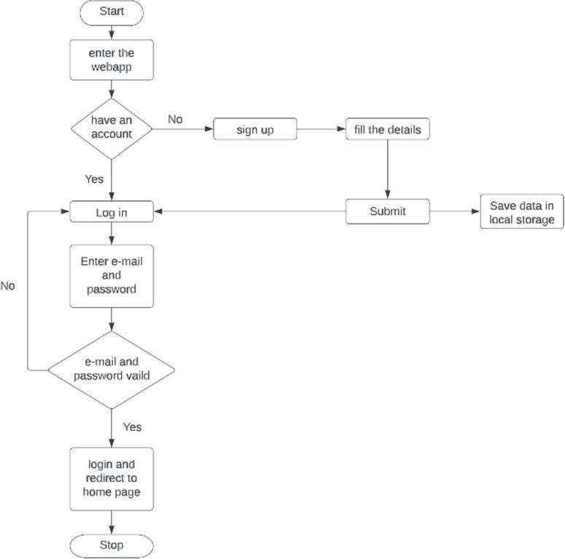

**Fig 5.9 Login Page Flowchart**

17

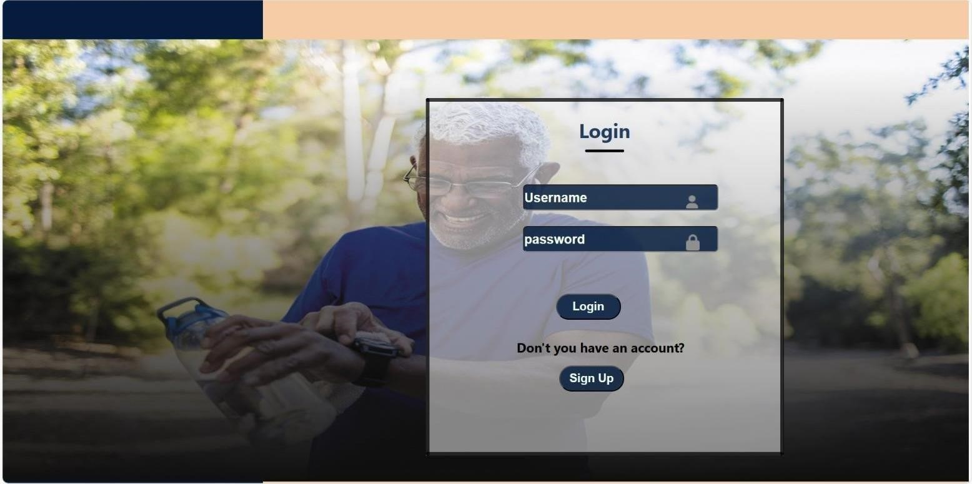

#### Fig 5.10 Login Page

**Js Code :**

import React,{useState} from 'react' import './Newregister.css';

import email_icon from '../Fpage/email.png' import person_icon from '../Fpage/person.png' import password_icon from '../Fpage/password.png' import { useDispatch } from 'react-redux'; import { Link, useNavigate } from 'react-router-dom'; import { login } from './userSlice'; export default function Newregister() {

const nav=useNavigate(""); const[username,setUsername]=useState(""); const[password,setPassword]=useState("");

const dispatch=useDispatch();

18

{

e.preventDefault();

if(username.length==0||password.length==0){ alert("Enter all fields")

}

else if (username && password) {

dispatch(login(username)); nav("/"); }

} return (

<div className='bgrect'>

<div className='bgrect1'>

<div className='pic'><img src="https://drivefordti.com/wp-/>

</div>

<div className='boxy33'></div>

<div className='bgrect2'>

<div className='underline2'></div>

<div className='header'>

<div className='text'>Login</div>

<div className='underline'></div>

</div>

<div className='fpassword'>Don't you have an account?</div>

<div className='form1'>

<form onSubmit={handleSubmit}>

<div className='image1'>

<img src={person_icon} height={20}></img>

</div>

<div className='image2'>

<img src={password_icon} height={25}></img>

</div>

<input type="text" placeholder= 'username' value={username} onChange={ (e)=>setUsername(e.target.value)} name='username' required/><br></br>

<input type="Password" placeholder='password' value={password} onChange={ (e)=>setPassword(e.target.value)} name='password'/><br></br>

<Link to="/"> <button type="submit" className='button1' onClick={handleSubmit}>Login</button></Link>

</form></div>

<Link to="/log"><button type="submit" className='button2'>Register</button></Link>

<div className='line3'></div>

<div className='line4'></div>

<div className='line5'></div>

</div>

</div>

</div>

) }

### 5.2.3 REGISTER PAGE

A register page enables users and organizations to independently register and gain access to your system. It is common to have multiple signup pages depending on the types of people and organizations you want to register. In this article you will learn about the different types of signup pages, how to configure them and related functionality. Global Administrator access is required to create and modify signup pages.

20

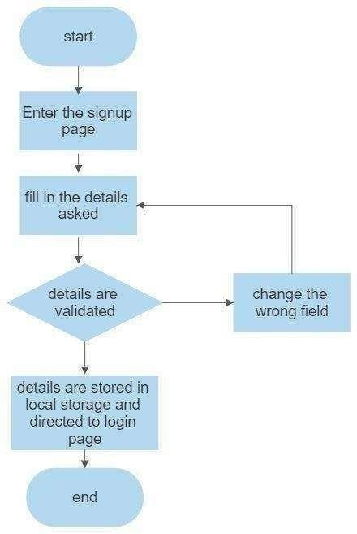

**Fig 5.11 Register Page Flowchart**

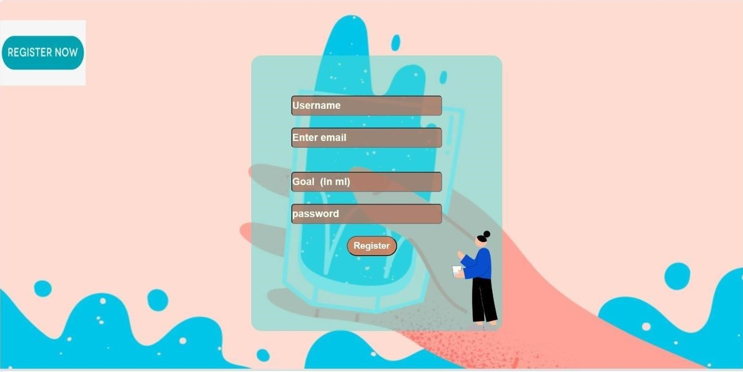

#### Fig 5.12 Register Page

**Js code:**

import React from 'react' import { Link } from 'react-router-dom'; import { useState } from 'react'; import { useNavigate } from 'react-router-dom';

import '../Fpage/person.png'; import '../Fpage/password.png'; import '../Fpage/email.png'; import '../Fpage/person.png';

export default function Register() {

const nav=useNavigate("");

const[username,setUsername]=useState(""); const[password,setPassword]=useState(""); const[gender,setGender]=useState(""); const[weight,setWeight]=useState(""); const[selects,setSelects]=useState();

const[age,setAge]=useState("");

const authenticate=(e)=>{

e.preventDefault(); if(username.length===0||password.length==0){

alert("Enter all fields")

}

else {

nav("/log")

} }

return (

<div className='full'>

<div className='photo'>

<div className='glass'>

<div className='form2'>

<form >

<input type="text" placeholder= 'Username' value={username} onChange={

(e)=>setUsername(e.target.value)} name='username' required/><br></br>

<input type="text" placeholder='Gender' value={gender} onChange={

(e)=>setGender(e.target.value)} name='gender'/><br></br>

<input type="number" placeholder='Weight' value={weight} onChange={

(e)=>setWeight(e.target.value)} name='weight'/><br></br>

<input type="number" placeholder='Age' value={age} onChange={

(e)=>setAge(e.target.value)} name='age'/><br></br>

<Link to ="/login"><button type="submit" className='button' onClick={authenticate}>Register</button></Link></form>

</div>

</div>

</div>

</div>

)

}

### 5.2.4 TODAY PAGE

This page allows users to set your water intake goal for a particular day.

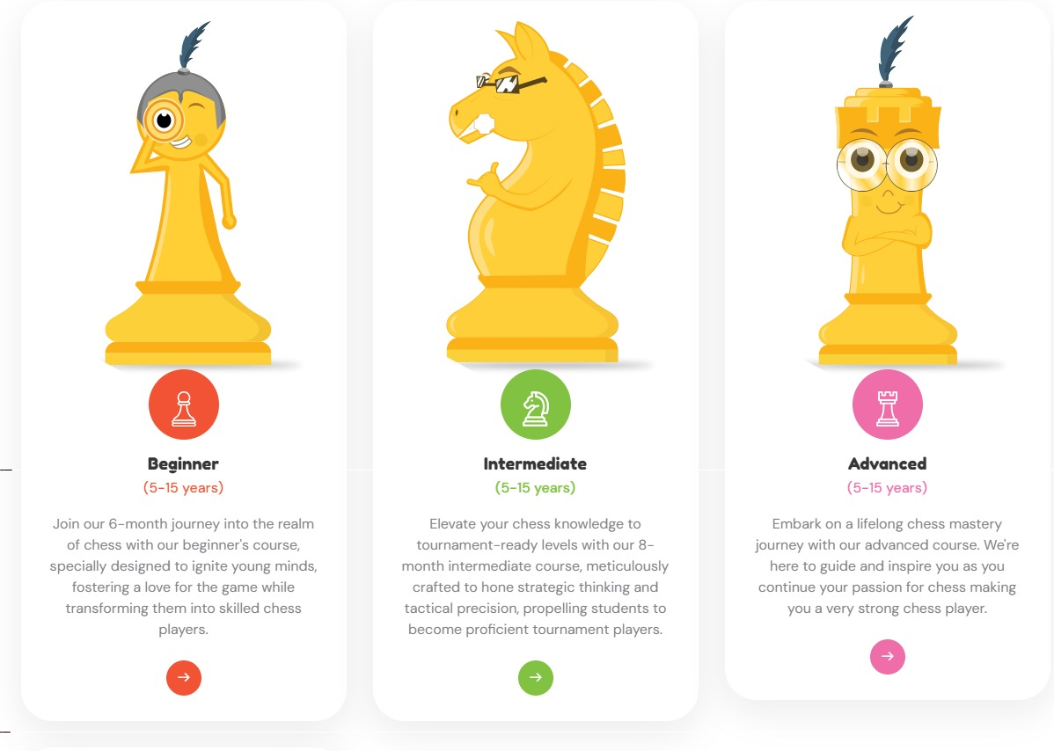

#### Fig 5.13 Today Page

**Js code :**

import React, { useState, useEffect } from 'react'; import axios from 'axios'; import Nave from './Nave';

function TodayPage() {

const [container, setContainer] = useState('Cup'); const token = localStorage.getItem('token'); const username = localStorage.getItem('username'); const [lastDailyTotal, setLastDailyTotal] = useState(null);

useEffect(() => {

axios

.get(http://localhost:8080/auth/history/${username})

.then((response) => { if (response.data.length > 0) {

setLastDailyTotal(response.data[response.data.length - 1].dailyTotal);

}

})

.catch((error) => {

console.error('Error fetching last dailyTotal:', error);

});

}, [username])

const handleLogIntake = (selectedContainer) => { let iconAmount = 0;

if (selectedContainer === 'Cup') { iconAmount = 250;

} else if (selectedContainer === 'Glass') { iconAmount = 500;

} else if (selectedContainer === 'Bottle') {

iconAmount = 750;

}

const newTotal = lastDailyTotal !== null ? lastDailyTotal + iconAmount : iconAmount; setLastDailyTotal(newTotal);

axios

.post(http://localhost:8080/auth/log-container/${username}, { container: selectedContainer,

})

.then((response) => {

})

.catch((error) => {

console.error('Error logging intake:', error);

}); }; return (

<div>

<div className="goalpage">

<h2>Log Water Intake</h2>

<div>

<label>Container:</label>

<select value={container} onChange={(e) => setContainer(e.target.value)}>

<option value="Cup">Cup</option>

<option value="Glass">Glass</option>

<option value="Bottle">Bottle</option>

</select>

</div>

<button onClick={() => handleLogIntake(container)}>Log Intake</button>

<h3>Last Daily Total</h3>

<p>{lastDailyTotal !== null ? lastDailyTotal : 'Loading...'}</p>

<Nave />

</div>

</div>

);

}

export default TodayPage;

### 5.2.5 HISTORY PAGE

This page displays a graph of water intake records for past 7 days.

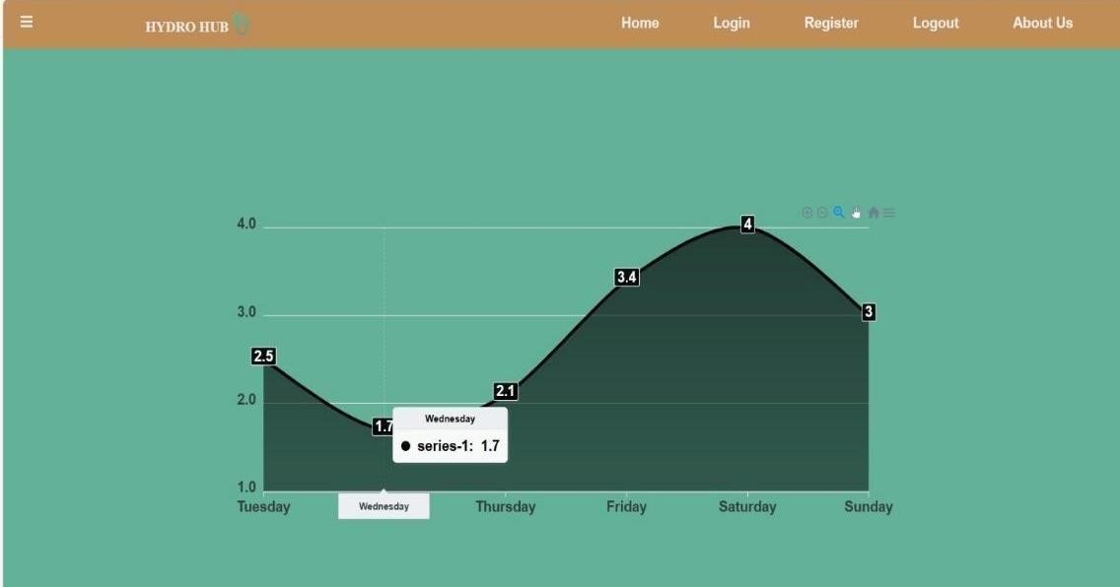

#### Fig 5.14 History page

**Js Code :**

import React,{useState} from 'react' import Chart from "react-apexcharts"; import './History.css'

export default function History() { const [state,setState]=useState({ options: { chart: {

id:"basic-bar" },

xaxis: { categories: ["Tuesday","Wednesday","Thursday","Friday","Saturday","Sunday"],

}, colors: ["black","black","black","black","black","black"],

}, series: [ { name: "series-1",

data: [2.5,1.7,2.1,3.4,4.0,3.0]

}

]

}

)

return (

<div className="hisfull">

<div className='chart'>

<div className='col-4'>

<Chart options={state.options} series={state.series} type="area" width="900"

height={400}

/>

</div>

</div>

</div>

) }

### 5.2.6 SUGGESTER PAGE

This page shows the suggestion of water intake goal for any user by considering few factors like age, weight, climate and activity level.

#### Fig 5.15 Suggester page

**Js Code :**

import React ,{useState} from 'react'

import gify from '../Fpage/healthy-water-drinking-water.gif' import './Suggestor.css' import suggcir from '../Fpage/water_loader.gif'

export default function Suggestor() {

const [age, setAge] = useState(''); const [weight, setWeight] = useState('');

const [activityLevel, setActivityLevel] = useState('');

const [climate, setClimate] = useState('');

const [waterIntake, setWaterIntake] = useState(null); const calculateWaterIntake = (e) => {

e.preventDefault(); const baseIntake = 0.035;

const adjustedIntake = baseIntake * weight;

let activityMultiplier = 1.0; if (activityLevel === 'low') { activityMultiplier = 0.5;

} else if (activityLevel === 'moderate') { activityMultiplier = 0.75;

} else if (activityLevel === 'high') { activityMultiplier = 1.0;

}

let climateMultiplier = 1.0; if (climate === 'hot') { climateMultiplier = 1.2;

} else if (climate === 'cold') { climateMultiplier = 0.8;

}

const totalIntake = adjustedIntake * activityMultiplier * climateMultiplier; setWaterIntake(totalIntake);

}; return (

<div className='suggfull'>

<div className='giffy'><img src={gify} height={500} width={900}></img>

<div className='sugg'>

<h2>Water Intake Calculator</h2>

<form onSubmit={calculateWaterIntake}>

<button type="submit" >Calculate</button> <br />

<br/>

<input type="number" placeholder='Enter your age' value={age} onChange={(e) => setAge(e.target.value)} />

<br />

<input type="number" placeholder='Enter your weight-kg)' value={weight} onChange={(e) => setWeight(e.target.value)} />

<br />

<select value={activityLevel} onChange={(e) => setActivityLevel(e.target.value)}>

<option value="">Select an Activity Level</option>

<option value="low">Low</option>

<option value="moderate">Moderate</option>

<option value="high">High</option>

</select>

<br />

<select value={climate} onChange={(e) => setClimate(e.target.value)}>

<option value="">Select a Climate</option>

<option value="average">Average</option>

<option value="hot">Hot</option>

<option value="cold">Cold</option>

</select>

</form></div>

{waterIntake !== null && (

<div className='recom'>

<h3>daily intake<br></br> level</h3>

<div className='result'>

<p>{waterIntake.toFixed(2)} l</p>

</div>

</div>

)}

</div>

</div>

)

### 5.2.7 FEEDBACK PAGE

The Feedback Page is designed to collect valuable input from users,

allowing them to share their thoughts, suggestions, and experiences to help us improve our services. Your feedback is essential in shaping our platform to better meet your needs and expectations.

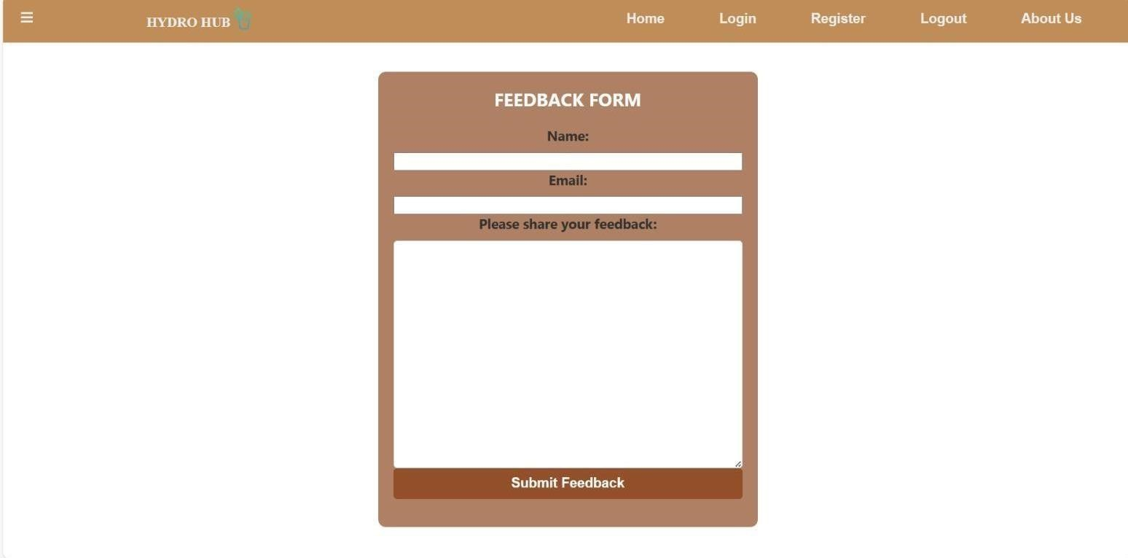

**Fig 5.16 Feedback Page**

**Js Code :**

import React, { useState } from 'react'; import './FeedbackForm.css' function FeedbackForm() {

const [feedback, setFeedback] = useState(''); const [submitted, setSubmitted] = useState(false); const handleFeedbackChange = (e) => {

setFeedback(e.target.value);

};

const handleSubmit = (e) => {

e.preventDefault(); setSubmitted(true);

};

return (

<div className=”feedback-form”>

<h2>Feedback Form</h2>

{submitted ? (

<p>Thank you for your feedback!</p>

) : (

<form onSubmit={handleSubmit}>

<label htmlFor=”feedback”>Please share your feedback:</label>

<textarea id=”feedback” name=”feedback” rows="4" value={feedback}

onChange={handleFeedbackChange}

required

></textarea>

<button type="submit">Submit Feedback</button> </form>

)}

</div>

); } export default FeedbackForm;

### 5.2.8 FAQ PAGE

The FAQ page serves as a comprehensive resource, addressing common questions and providing clear, concise answers to assist users in navigating our platform effortlessly. It's a valuable reference to quickly find solutions and gain insights into various aspects of our services.

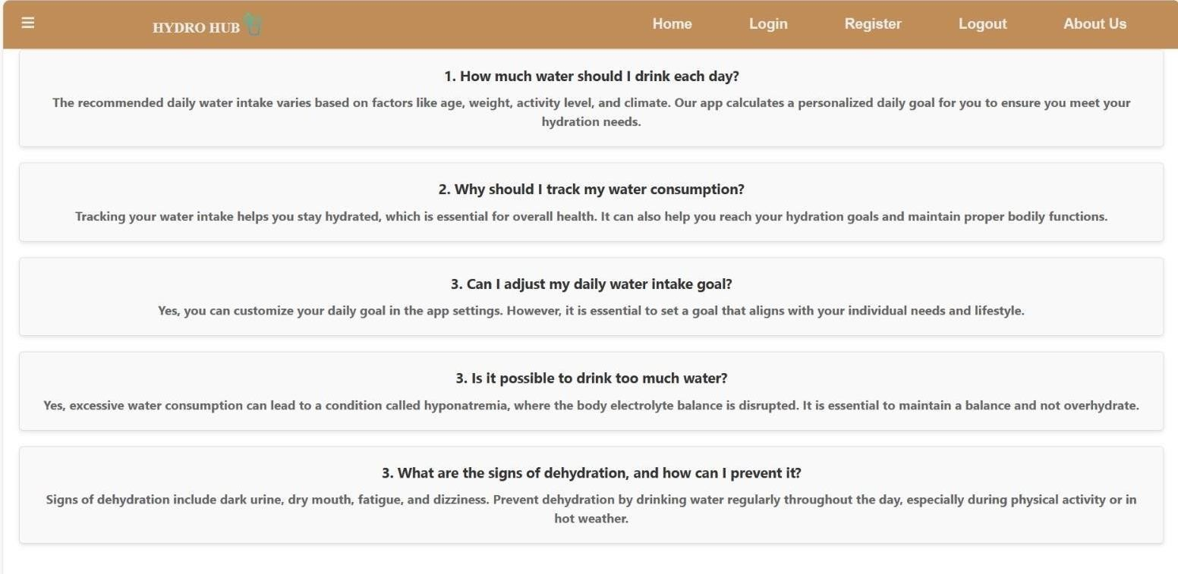

#### Fig 5.17 FAQ Page

**Js Code :**

import React from 'react'; import './FAQPage.css' function FAQPage()

{ const faqItems = [

{ question: '1. How much water should I drink each day?',

answer:

'The recommended daily water intake varies based on factors like age, weight, activity level, and climate. ',

},

{ question: '2. Why should I track my water consumption?', answer:

'Tracking your water intake helps you stay hydrated, which is essential for overall health.',

},

{ question: '3. Can I adjust my daily water intake goal?',

answer:

'Yes, you can customize your daily goal in the app settings. However, it is essential to set a goal that aligns with your individual needs and lifestyle.', },

{ question: '3. Is it possible to drink too much water?',

answer:

'Yes, excessive water consumption can lead to a condition called hyponatremia, where the body electrolyte balance is disrupted. It is essential to maintain a balance and not overhydrate.',

},

];

return (

<div className="faq-page">

<h2>Frequently Asked Questions</h2>

<ul className="faq-list">

{faqItems.map((item, index) => (

<li key={index} className="faq-item">

<div className="faq-question">{item.question}</div>

<div className="faq-answer">{item.answer}</div> </li>

))}

</ul>

</div>

);

}

export default FAQPage;

### 5.1.1 ABOUT PAGE

Our About Us page offers insight into our organization's mission, values,

and the team behind our platform, helping you get to know us better and understand our commitment to excellence. Discover our story, goals, and the passion driving our efforts to provide you with the best experience possible.



#### Fig 5.18 About page

**Js Code :**

import pic1 from '../Fpage/pic 1.png'; import pic2 from '../Fpage/pic 2.png'; import pic3 from '../Fpage/pic3.png' import './About.css'

export default function About() { return (

<div>

<div className='Apic1'><img src={pic1} height={400} width={600}></img></div>

<div className='Apic2'><img src={pic2} height={400} width={600}></img></div>

<div className='Apic3'><img src={pic3} height={400} width={600}></img></div>

<div className='Aboxy1'><p>Users can review their historical water consumption data to track their progress over time. This can help them see whether they are meeting their hydration goals and making positive changes to their habits. By reviewing their past water intake, users can set realistic and personalized hydration goals. For instance, if they notice that they consistently fall short of their recommended daily water intake, they can set a goal to increase their consumption gradually.</p></div>

<div className='Aboxy2'><p>A water intake calculator takes into account various factors such as age, weight, activity level, and climate to provide personalized hydration goals. This helps individuals determine how much water they should drink daily based on their specific needs.The calculator helps users ensure they consume an adequate amount of water to meet their daily hydration requirements. </p></div>

<div className='Aboxy3'><p>Achieving daily water intake goals can be a source

of personal accomplishment and motivation. Reminders keep individuals on track to reach their hydration objectives.</p></div>

</div>

)

}

### 5.1.2 PRIVACY POLICY PAGE

Our Privacy Policy page outlines how we handle and protect your

personal information, ensuring transparency in how your data is collected, used, and safeguarded. We are committed to maintaining your privacy and providing you with a secure and trustworthy experience on our platform.

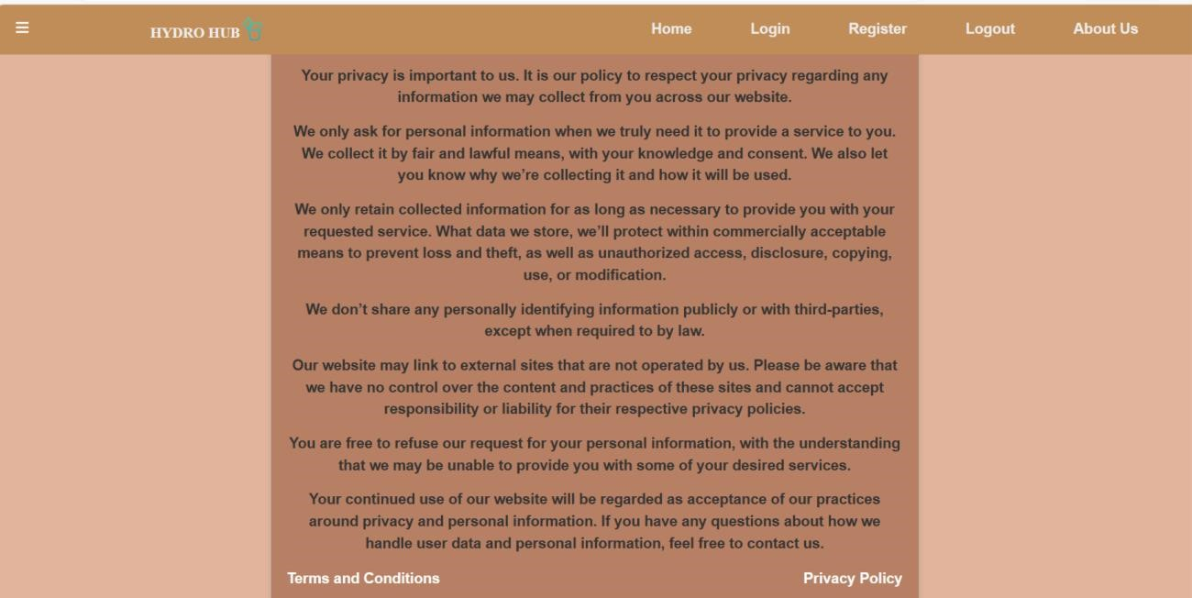

#### Fig 5.19 Privacy policy page

**Js Code:**

import React from 'react' import Sidebar from '../Bar/Sidebar'; import './Privacypolicy.css';

export default function Privacypolicy()

{ return (

<div>

<Sidebar/>

<div className='ppfull'>

<div className='ppara'>

<p>This Privacy Policy describes how our website collects, uses, and protects personal information when you visit our website or use our services related to online wildlife watching tour.</p>

<div className='para'><br/>

<p><span className='ppspan'>Personal Information: </span> We may collect

personal information, such as your name, email address, and location, when you voluntarily provide it to us.

</p>

</div>

<div className='pphead1'>

<h4>How We Use Your Information</h4>

<div className='para'><br/>

<p>We use the collected information for the following purposes:</p> </div>

<div className='para'><br/>

<p>1. To provide and improve our online wildlife watching tour services.</p> <p>2. To personalize your experience and offer relevant content.</P> </div>

<div className='pphead1'>

<p><b>Sharing Your Information</b></p>

<p>We do not sell, trade, or rent your personal information to third parties. We may share your information with:</p>

</div>

<div className='para'><br/>

<p>1.Partners and affiliates for marketing and promotional purposes.</p>

<p>2.Third-party service providers that assist us in operating our website and delivering our services.</p>

</div>

<div className='para'>

<p>We take reasonable steps to protect your personal information from unauthorized access, disclosure, or alteration. However, no data transmission</p>

</div>

<div className='pphead1'>

<p><b>Contact Us</b></p>

</div>

}

### 5.1.3 TERMS & CONDITION PAGE

Our Terms and Conditions page outlines the rules and guidelines governing the use of our platform, ensuring clarity and fairness in the interactions between users and our services. By accessing and using our platform, you agree to abide by these terms, promoting a safe and respectful online environment.

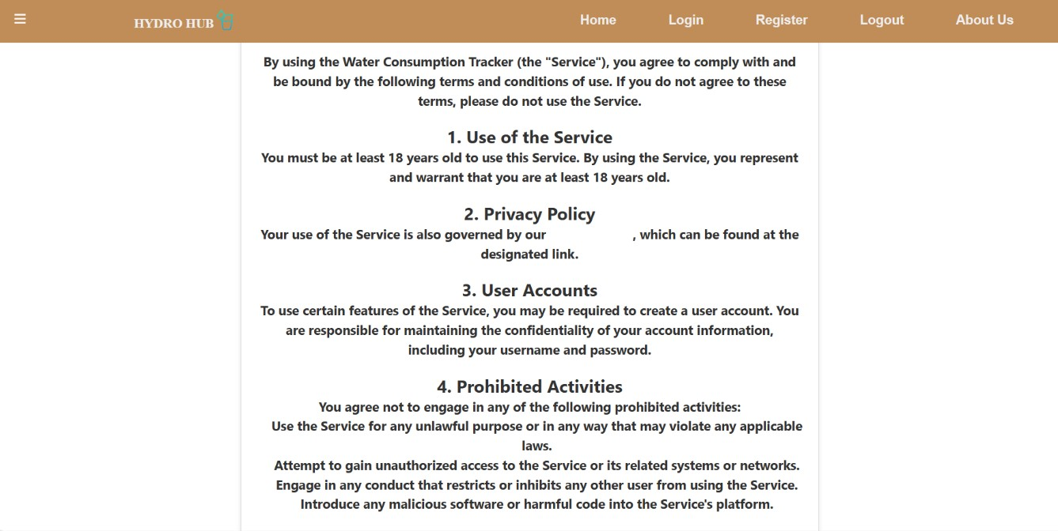

**Fig 5.20 Terms & Condition page**

**Js Code:**

import React from 'react' import Sidebar from '../Bar/Sidebar'; export default function Termsandcondition()

{ return (

<div>

<Sidebar/>

<div className='tc-full'>

<div className='wrapper flex_align_justify'>

<div className='terms_condition'>

<div className='tc_item tc_head flex_align_justify'>

<div className='tc_icon'>

<span className='tc_icon1'><BsIcons.BsTerminal/></span> </div>

<div className='tc_text'>

<h2>TERMS OF SERVICE</h2>

<p>Last update on August 11 2023</p>

</div>

</div>

<div className='tc_item tc_body'>

<ol>

<li>

<h3>1.Terms of use</h3>

<p>By accessing and using this website, you agree to comply with and be

bound by these terms and conditions.</p>

</li>

<li>

<h3>2.Services Offered</h3>

<p>We provide online wildlife watching tour booking services. By booking a

tour through this website, you acknowledge that you have read and understood the specific tour details and requirements.</p>

</li><li>

<h3>5.Changes to Terms and Conditions</h3>

<p>We reserve the right to modify these terms and conditions at any time

without prior notice. Updated terms will be effective immediately upon posting on our website.</p>

</li> <li>

<h3>6.Governing Laws</h3>

<p>These terms and conditions are governed by and construed in accordance

exclusive jurisdiction of the courts </p></li>

<div className='tc_accept'>

<input type='radio' id='tc_accept'/>

<label>I accept the <a href="#">terms and conditions</a></label>

<div className='tc_item tc_foot flex_align'>

<button className='tc_decline_btn'><Link to='/'>Decline</Link></button>

<button className='tc_accept_btn'><Link to='/home'>Accept</Link></button>

</div>

</div>

</div>

)

### 5.1.4 FOOTER

The Footer page serves as a convenient navigational element at the bottom of our website, providing quick access to essential links, contact information, and important pages to enhance user accessibility and usability. It is designed to streamline your browsing experience and facilitate easy access to key resources.



#### Fig 5.21 Footer

**Js Code:**

import React from 'react' import { Link } from "react-router-dom"; export default function Footer() {

return (

<div className='footfull'>

<footer>

<div className='footer-col'>

<h4>Quick Links</h4>

<ul>

<li><Link to='/pp'><span className='fp'>Privacy policy</span></Link></li>

<li><Link to='/tc'><span className='fp'>Terms and

Condition</span></Link></li>

<li><Link to='/feedback'><span className='fp'>Feed

Back</span></Link></li>

<li><Link to='/faq'><span className='fp'>FAQ</span></Link></li></ul>

</div>

<div className='footer-col'>

<h4>Project</h4>

<ul>

<li><Link to='/place'>place</Link></li>

<li><Link to='/animel'>Animels</Link></li>

<li><Link to='/video'>Videos</Link></li>

<li><Link to='/image'>Images</Link> </ul></div>

<div className='footer-col'>

<h4>Company</h4><ul>

<li><Link to='/about'>About Us</Link></li>

<li><Link to='/contactus'>Contact Us</Link></li></ul></div>

<div className='footer-col'>

<h4>Follow Us</h4>

<div className='sociellink'>

<Link to='https://[www.facebook.com/profile.php?id=100093687843994'>](http://www.facebook.com/profile.php?id=100093687843994%27)<span className='sicon'><AiIcons.AiFillFacebook/></span></Link>

<Link to='https://[www.instagram.com/'>](http://www.instagram.com/%27)<span className='sicon'><BsIcons.BsInstagram/></span></Link>

<Link to='https://[www.linkedin.com/in/abi-chellappa-193837256/'>](http://www.linkedin.com/in/abi-chellappa-193837256/%27)<span className='sicon'><AiIcons.AiOutlineLinkedin/></span></Link>

<Link to='https://twitter.com/'><span className='sicon'><BsIcons.BsTwitter/></span></Link>

</div></footer>

</div>

)}

## CONCLUSION

42

**CHAPTER 6**

CONCLUSION

In conclusion, the establishment and utilization of a Chess Academy Portal represent a progressive and inclusive approach to promoting the timeless game of chess. By providing a centralized platform for enthusiasts to access academies, enroll in courses, and engage in a vibrant learning community, the portal fosters a culture of continuous improvement and skill development. As we navigate a world where strategic thinking and intellectual growth are increasingly valued, let us embrace the Chess Academy Portal as a catalyst for honing our analytical skills, fostering creativity, and building meaningful connections within the chess community. Through collective participation and individual dedication, we can elevate the art of chess and inspire future generations to appreciate its profound benefits and enduring legacy.

6.1 FUTURE SCOPE

The future of the Chess Academy Portal holds tremendous potential with advancements in technology and educational methodologies. Integration with smart devices and virtual reality platforms will offer immersive learning experiences, while data analytics and AI-driven tools will provide personalized recommendations and progress tracking. Mobile applications will facilitate on-the-go learning and interaction, enhancing accessibility and convenience for users worldwide. Additionally, partnerships with renowned chess masters and institutions will enrich the portal's content and establish it as a global hub for chess education and innovation. The next phase of development will focus on enhancing user experiences, expanding course offerings, and collaborating with industry leaders to solidify the portal's position as a premier destination for chess enthusiasts and learners.

## REFERENCES

43

### REFERENCES

1. All Basics [www.javatpoint.com](http://www.javatpoint.com/)
2. The basic diagram of the HTML/HTML5 5/24/201844

<http://www.modelrumahminimalis.co/html->menutemplatesfreedownload/69033.html/top-result-html-menu-templates- freedownloadinspirationalgenerous-menu-template-html-images-entry- levelresumetemplates-picture-2017-hdj5

1. [www.w3schools.com](http://www.w3schools.com/)
2. Fielding, R. T. (2000). Architectural Styles and the Design of Network-based Software Architectures.
3. React Documentation: https://reactjs.org/docs/getting-started.html
4. React Tutorial (MDN Web Docs):

https://developer.mozilla.org/enUS/Learn/Tools_and_testing/client